**PENGOLAHAN CITRA DIGITAL**

1. **CONTRAST ENCHANCMENT**

* SOURCE CODE

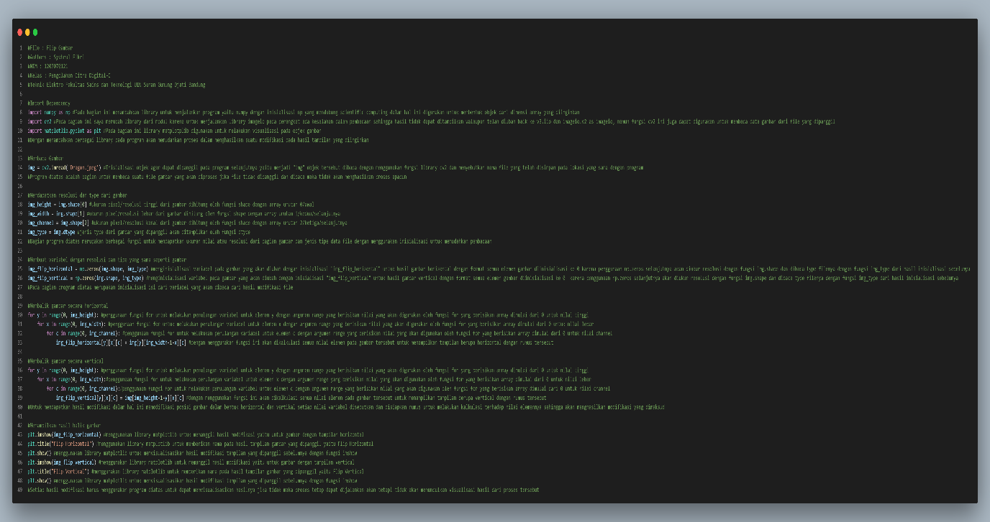

* OUTPUT

1. *Flip Horizontal*

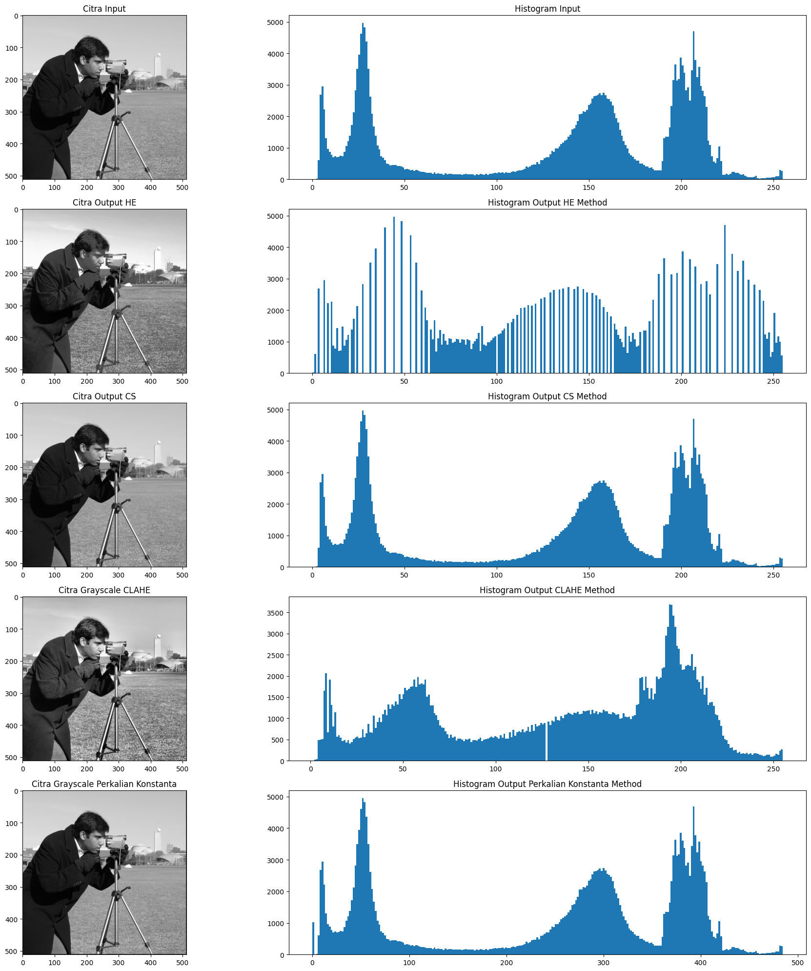

1. *Flip Vertical*

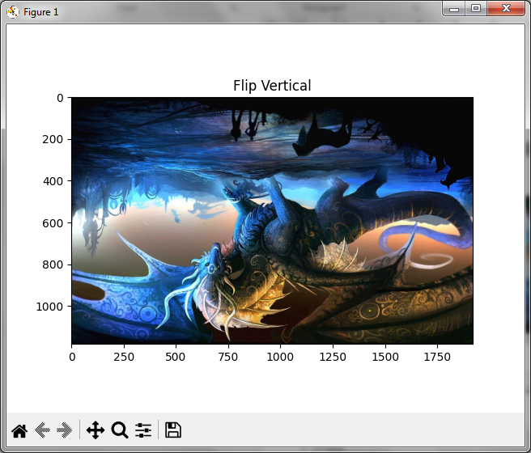

1. **GRAY LEVEL SLICING**

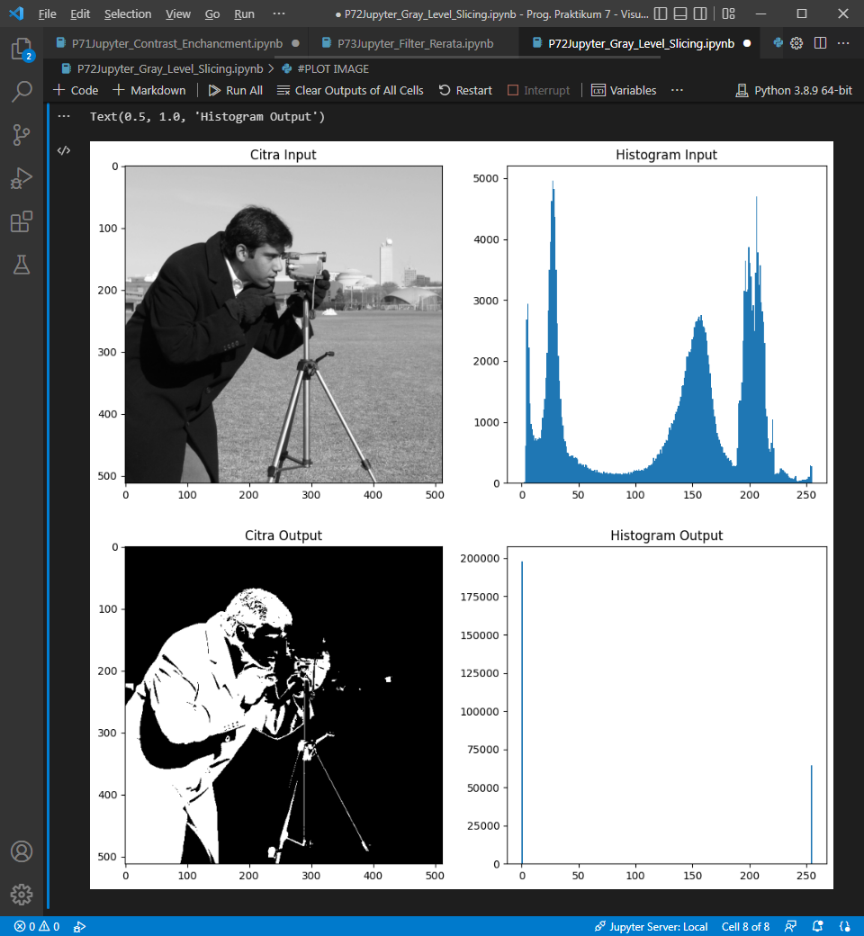

1. **FILTER RERATA**

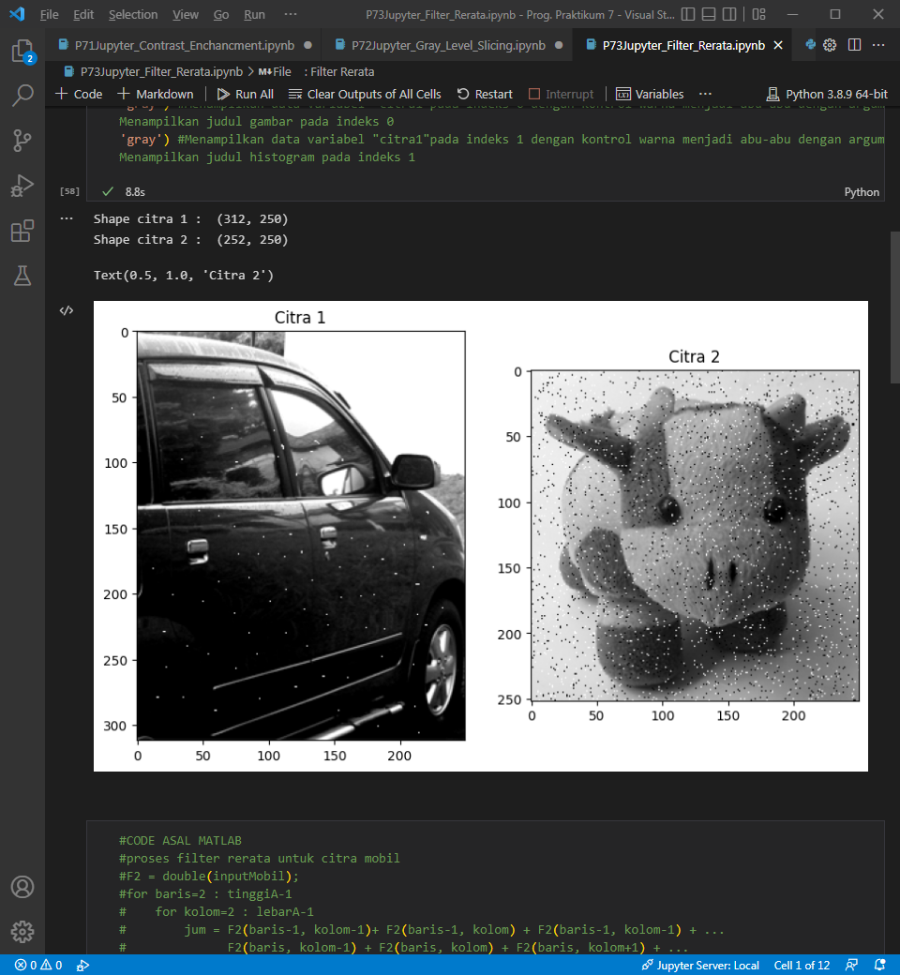

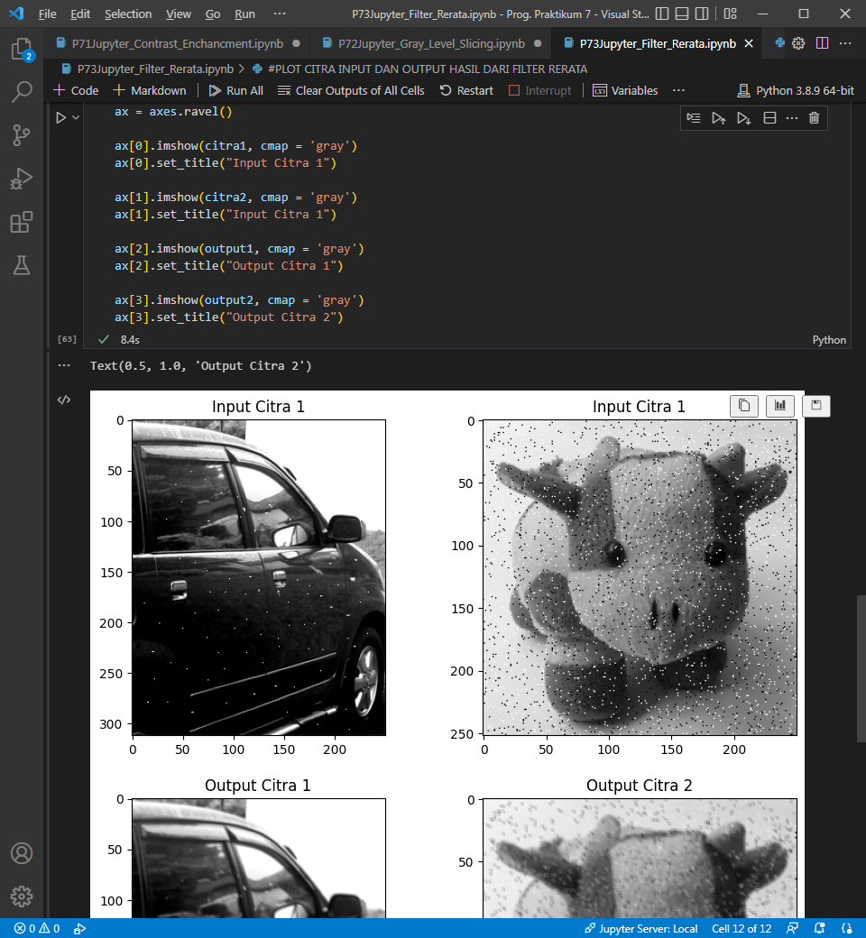

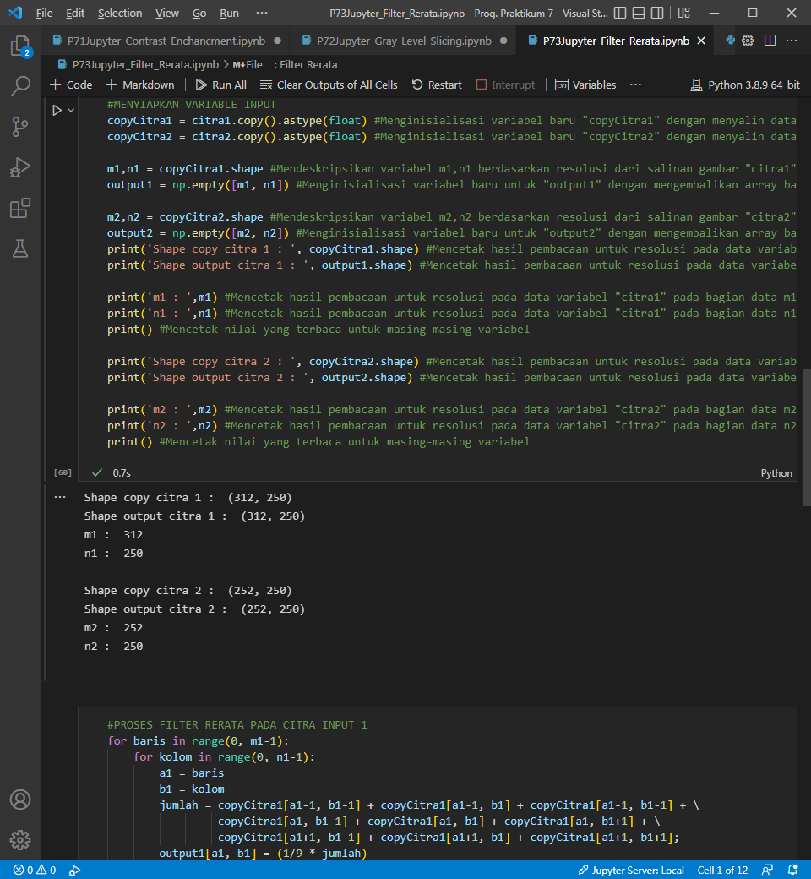

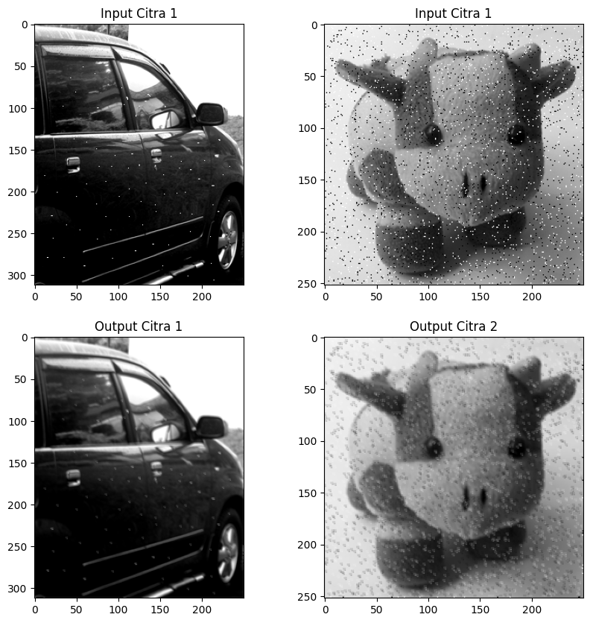

1. **FILTER MEDIAN**
2. **FILTER BATAS**
3. **KONVOLUSI**
4. **IMAGE FILTERING LPF, HPF, DAN THRESHOLDING**
5. **HISTOGRAM**
6. *MERUBAH GAMBAR MENJADI GRAYSCALE*

* SOURCE CODE

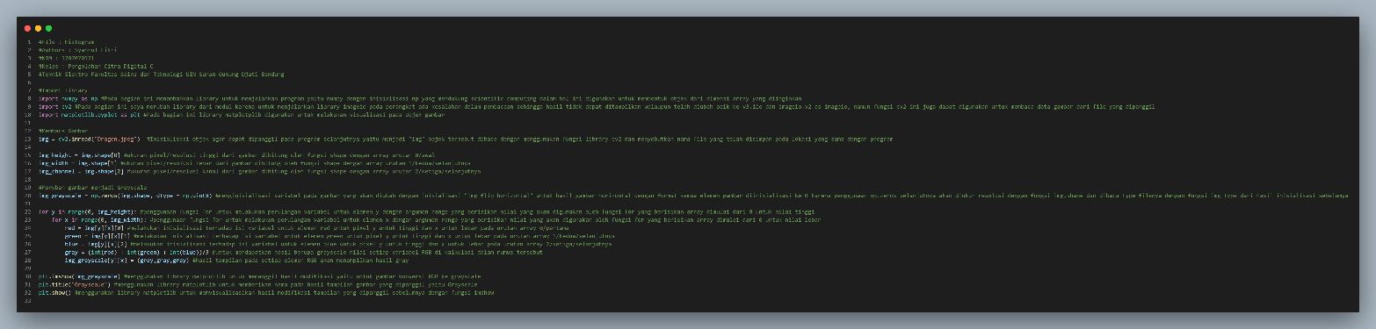

* OUTPUT

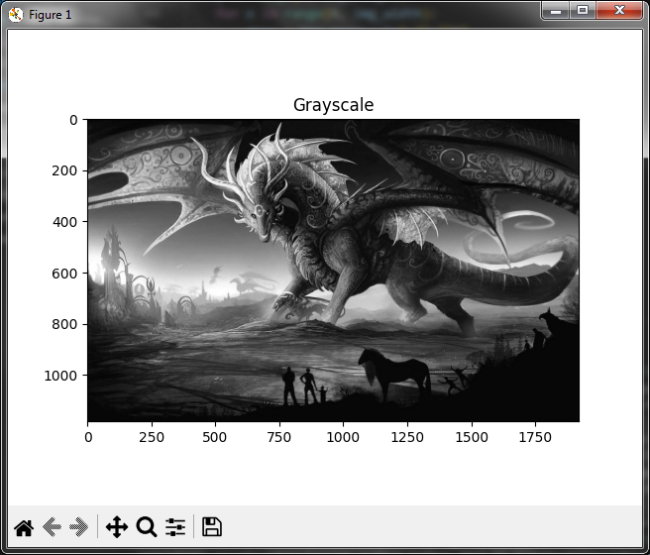

1. MENAMPILKAN HISTOGRAM GAMBAR GRAYSCALE

* SOURCE CODE

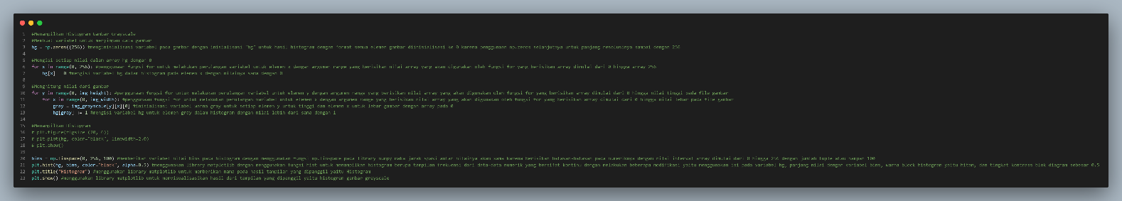

* OUTPUT

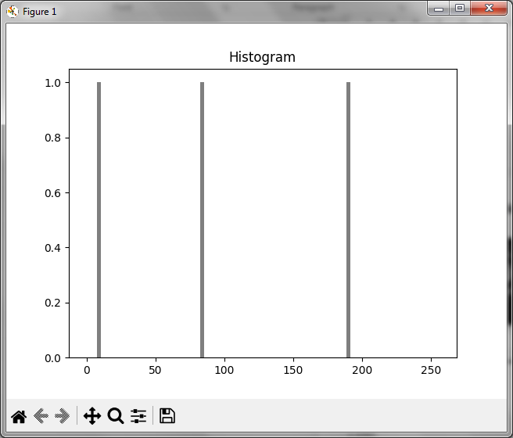

1. MENAMPILKAN HISTOGRAM GAMBAR RGB

* SOURCE CODE

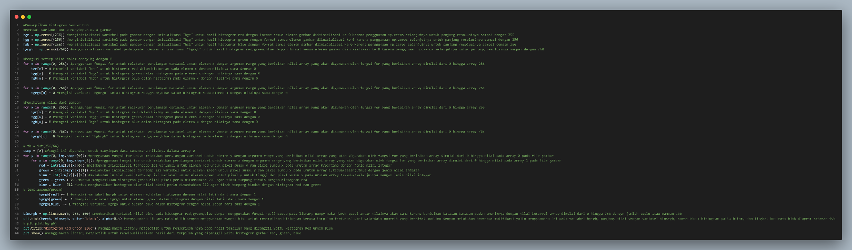

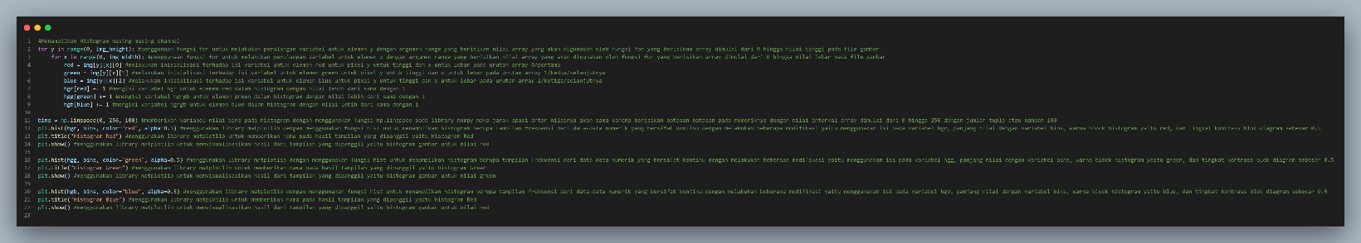

* OUTPUT

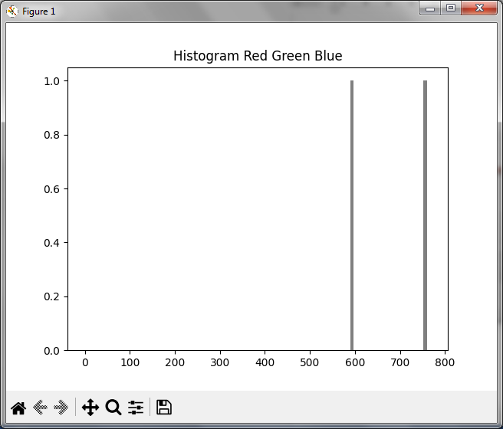

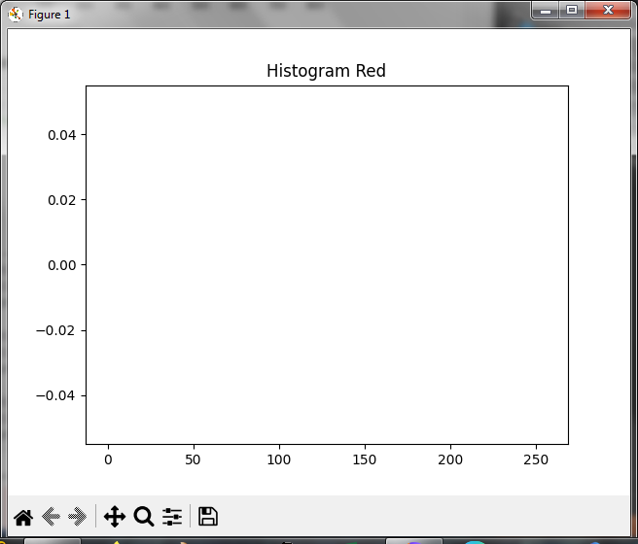

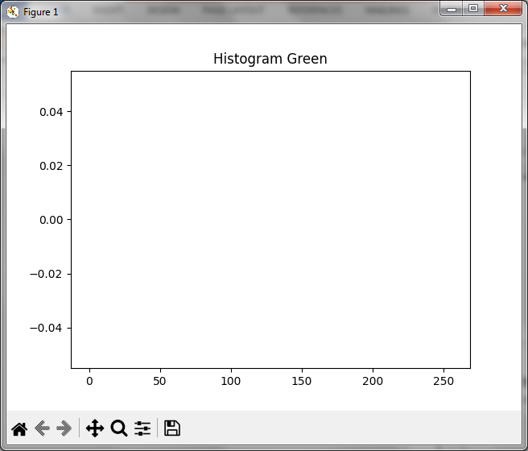

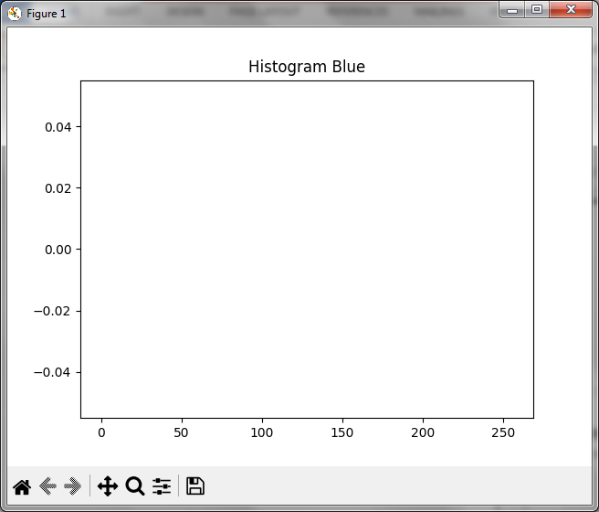

1. MENAMPILKAN HISTOGRAM GAMBAR KUMULATIF

* SOURCE CODE

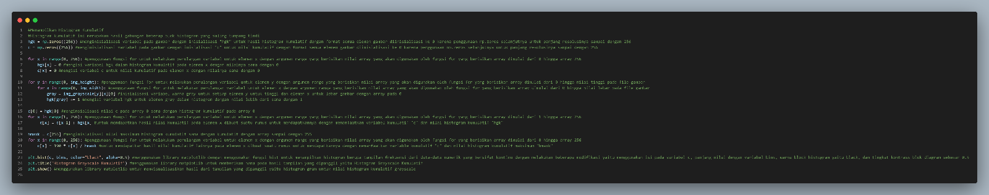

* OUTPUT

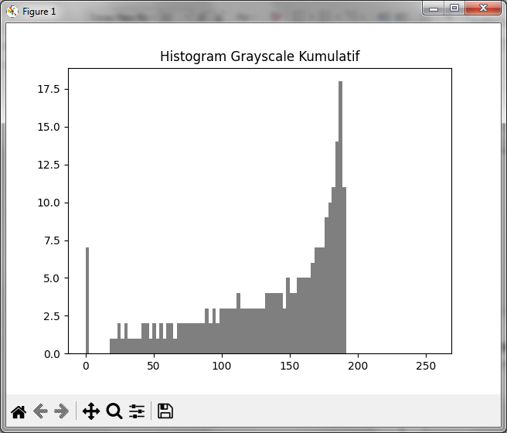

1. MENAMPILKAN HISTOGRAM GAMBAR HEQUALISASI

* SOURCE CODE

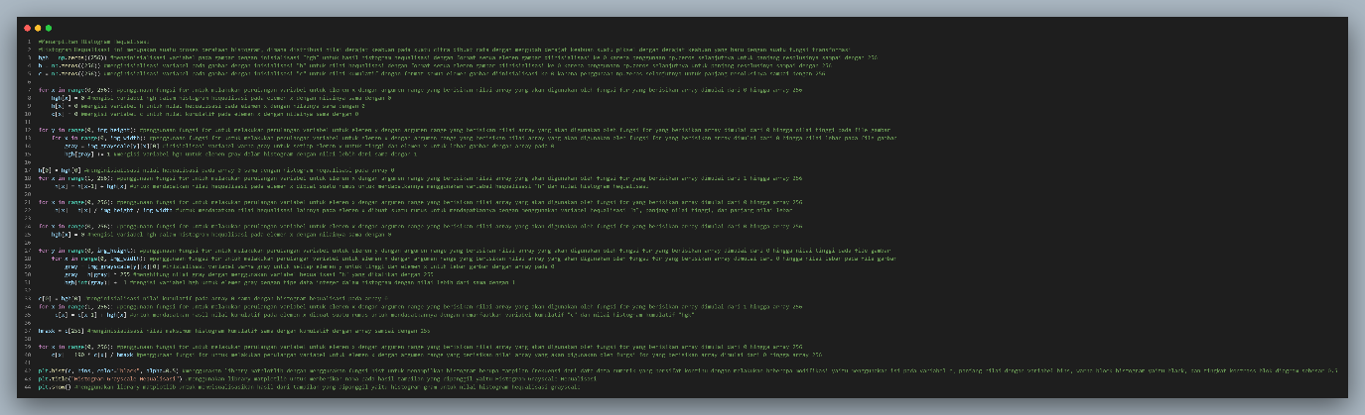

* OUTPUT

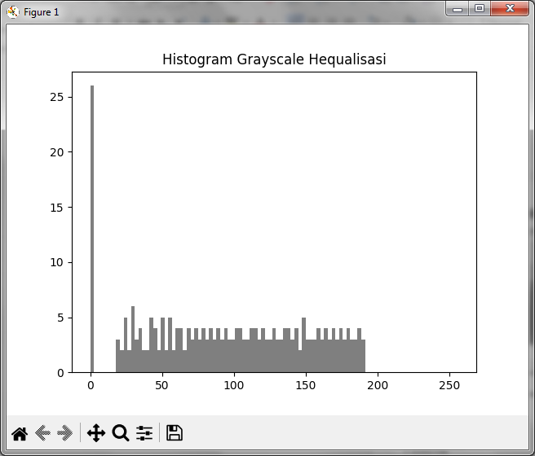

1. INVERSI
2. INVERSI GRAYSCALE

* SOURCE CODE

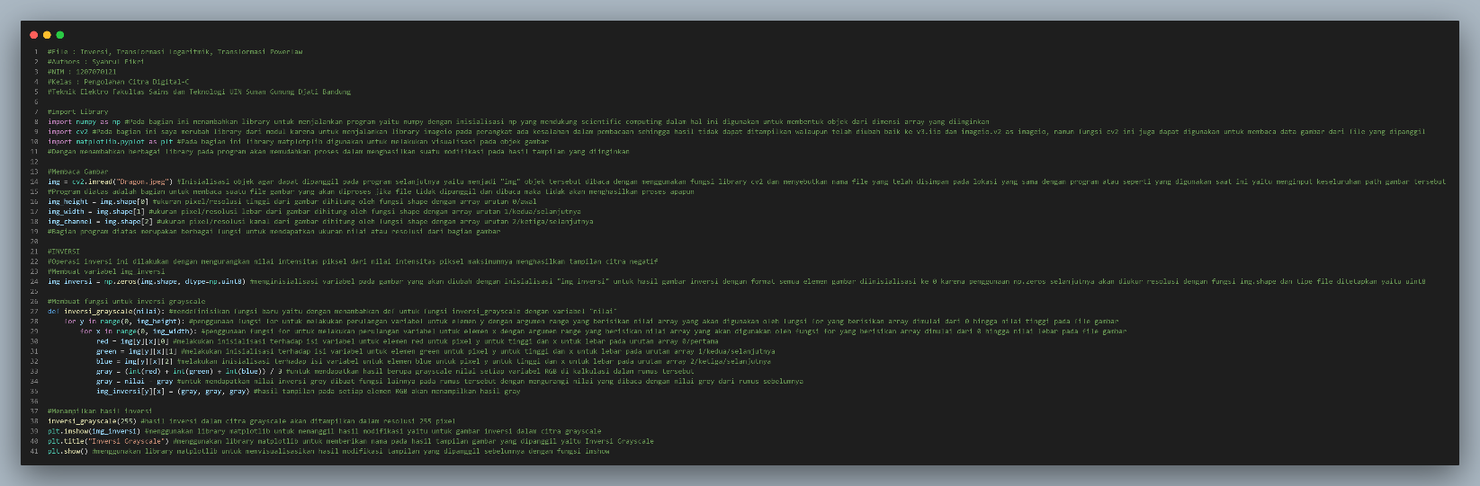

* OUTPUT

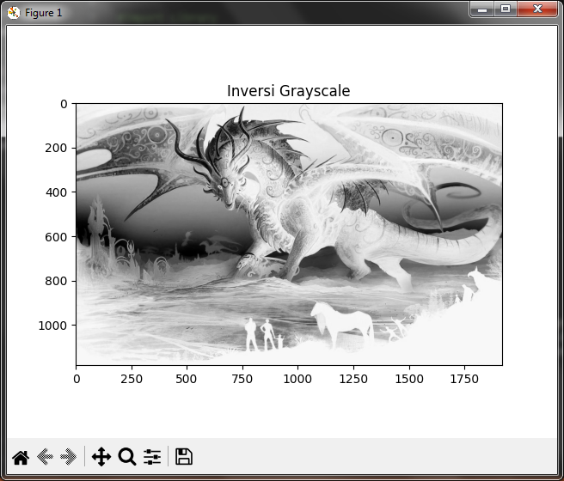

1. INVERSI RGB

* SOURCE CODE

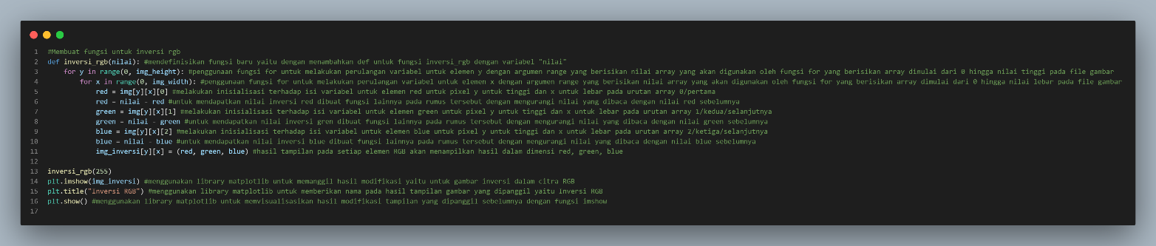

* OUTPUT

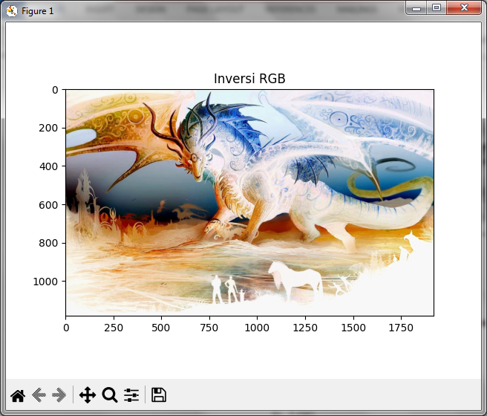

1. LOG

* SOURCE CODE

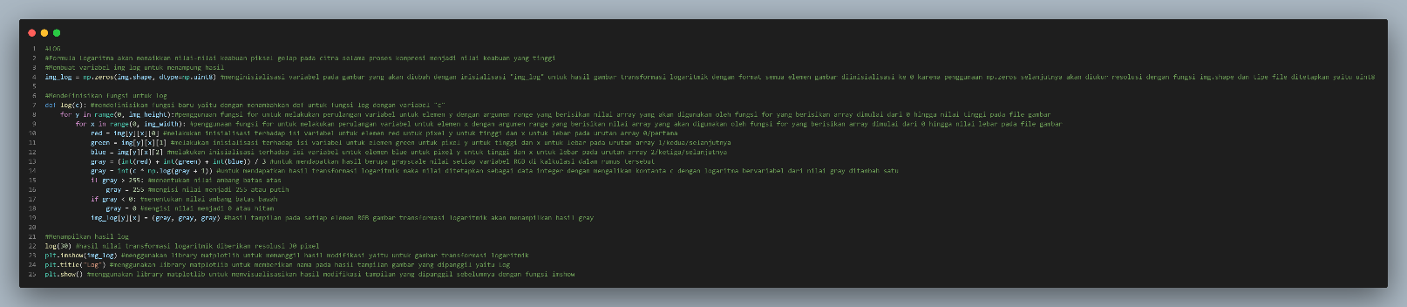

* OUTPUT

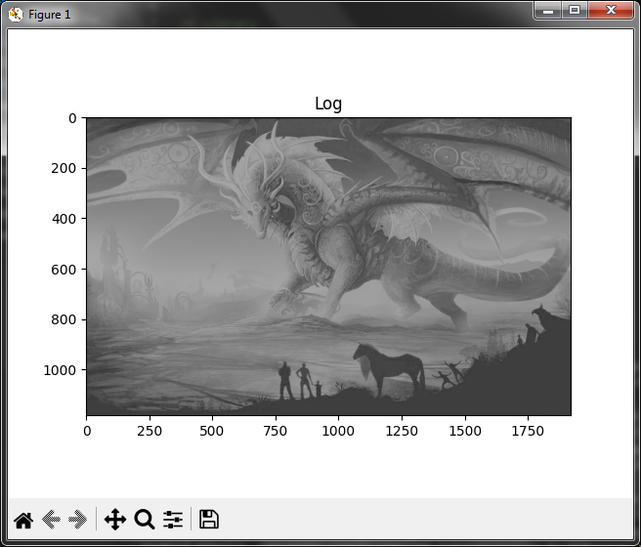

1. INVERSI & LOG

* SOURCE CODE

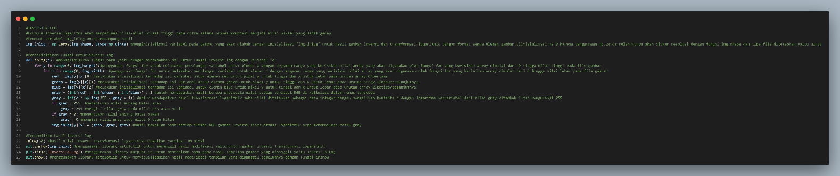

* OUTPUT

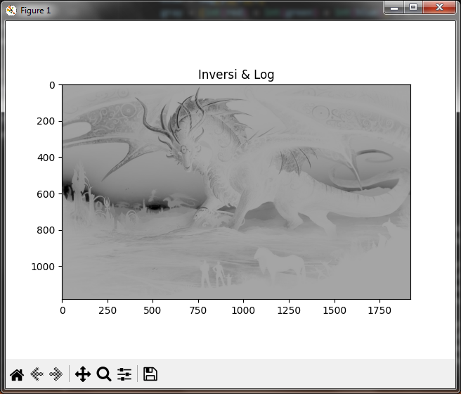

1. NTH POWER

* SOURCE CODE

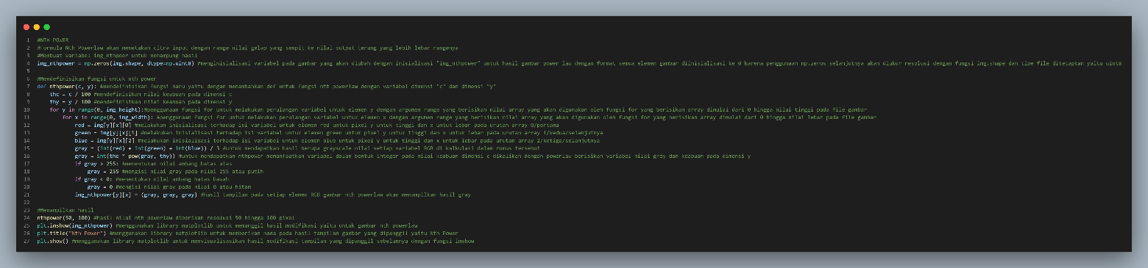

* OUTPUT

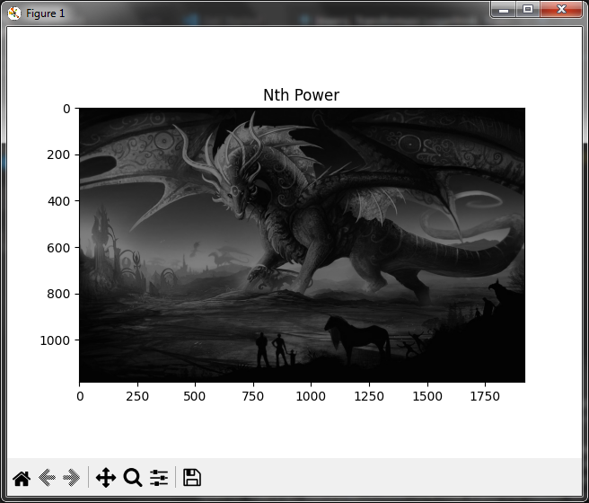

1. NTH ROOT POWER

* SOURCE CODE

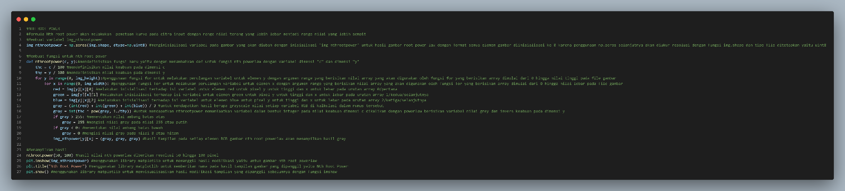

* OUTPUT

